**Input Format**

* The website accepts a .csv file as input using the upload button.

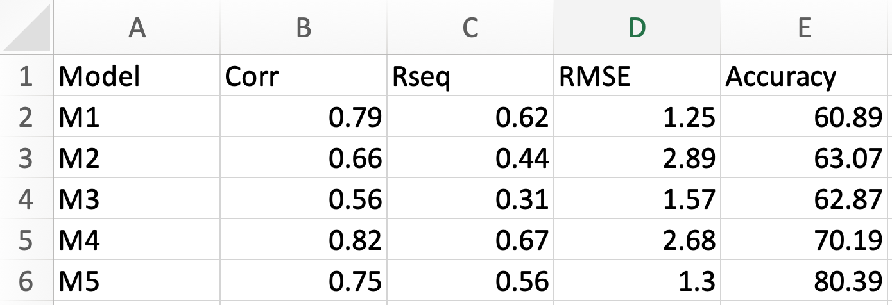

A sample input csv file

* First Row: Parameter Names
* First Column: Model Names

First Column will not be used in calculating Topsis score.

* A minimum of 3 columns (including ‘Model Name’ column) are required
* Weights are used as a percentage of total weight allocated and can be any positive floating point value except 0
* Impacts can be + or –

+ means higher the parameter value, better is the model

- means lower the parameter value, better is the model

* The website calculates and displays results applying Topsis method using input csv file, weights, and impacts. A ‘download file’ button is provided to download the results in .csv format.

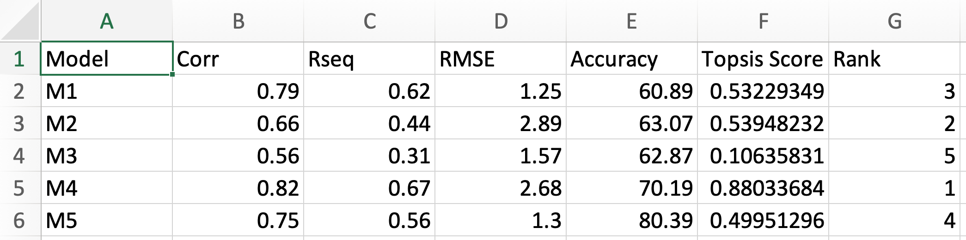

A sample output csv file